**Project Design Phase-I**

**Solution Architecture**

|  |  |
| --- | --- |
| Date | 10 September 2022 |
| Team ID | PNT2022TMID04437 |
| Project Name | Plasma Donor Application |
| Maximum Marks | 4 Marks |

***Solution Architecture:***

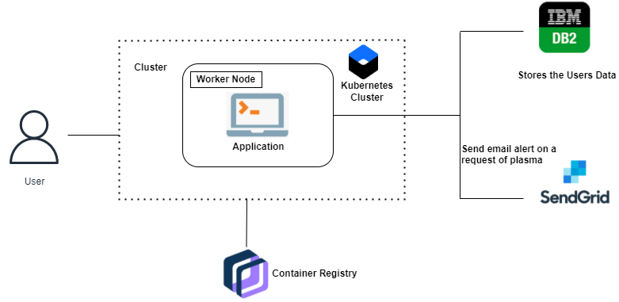

**KUBERNETES CLUSTER**

Kubernetes, also known as K8s, is an open-source system for automating deployment, scaling, and management of containerized applications Kubernetes, also known as K8s, is an open-source system for automating deployment, scaling, and management of containerized applications

**CONTAINER REGISTRY**

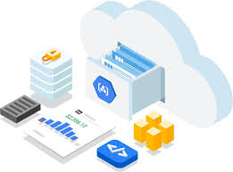

A container registry is a repository—or collection of repositories—used to store and access container images. Container registries can support container-based application development, often as part of DevOps processes. Container registries can connect directly to container orchestration platforms like Docker and Kubernetes.

**SENDGRID**

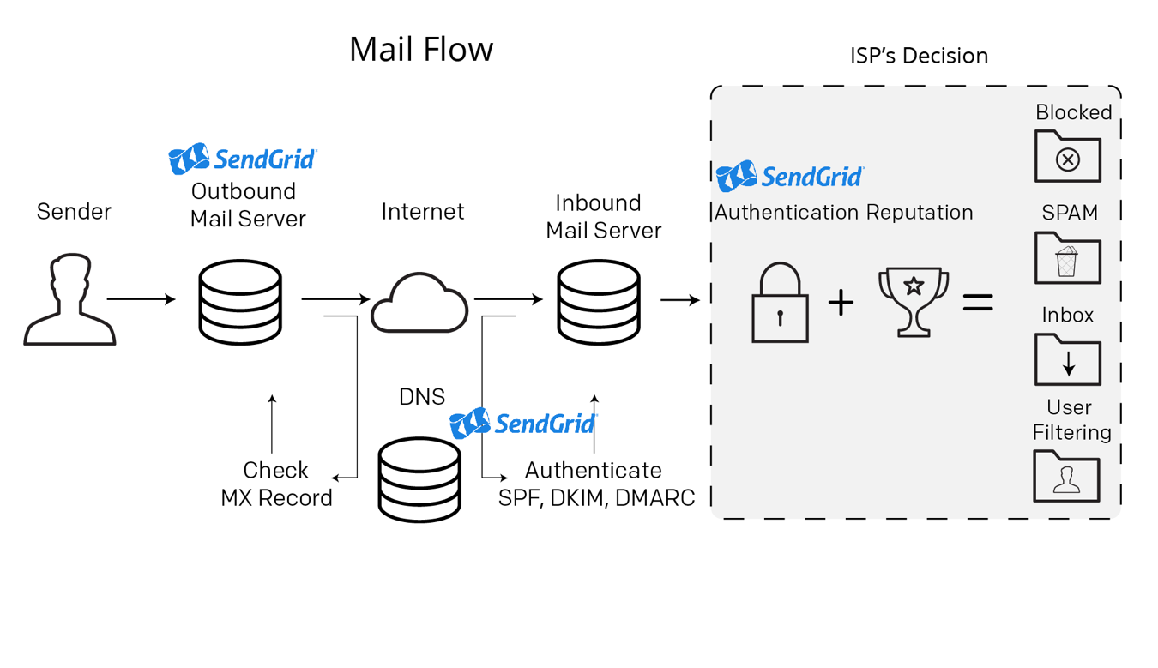First, a sender puts together the content that their recipients will love. Then it’s time for the “SMTP conversation” to take place. SMTP stands for Simple Mail Transfer Protocol, and this conversation is what makes email messages get from the sender to the recipient. It’s easiest to think of an SMTP conversation as a “handshake”. Imagine that a sender is a host at a party and all of the other guests are the recipients of the message. The host will shake every guest’s hand and during that “handshake” they will have this SMTP conversation. In the end, the guest (i.e. recipient and its recipient server) will determine if they will accept the message or not. In this scenario, you can think of SendGrid as a person at the party grabbing both the host’s and guest’s hands and making the handshake and discussion actually happen.

**IBM DATABASE2**

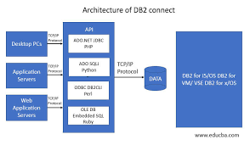

The architecture of the DB2 is mainly divided into the DB2 client and DB2 server. The DB2 server consists of different agents and subagents. The two important components are the prefetchers and the page cleaners which maintain the data in buffer pools for fast and effective retrieval of data.